DATA ANALYSIS INTERNSHIP – DAY 14 REPORT
Organization: Top Tech Developers
Topic Covered: Seaborn and Graph Creation
On Day 14 of the internship, different graph visualization techniques were practiced using Seaborn and Matplotlib in Google Colab. Various statistical and attractive visualization graphs were created using Seaborn functions for better understanding of data analysis and graphical representation.

Introduction
Seaborn is a Python data visualization library used to create attractive and statistical graphs easily. It is built on top of Matplotlib and provides simple functions for creating different types of visualizations with less coding.
Import Statement
import seaborn as sns
import matplotlib.pyplot as plt
Explanation
- seaborn → Statistical data visualization library
- matplotlib.pyplot → Graph plotting module
- sns and plt → Alias names used for easy access

Difference Between Matplotlib and Seaborn
Matplotlib | Seaborn
Basic visualization library | Built on Matplotlib
Needs more coding | Needs less coding
Simple graph design | Attractive graph design
Used for full customization | Used for statistical visualization
Manual styling required | Automatic styling available

Graph Creation using Seaborn
Different graphs were created using Seaborn functions.
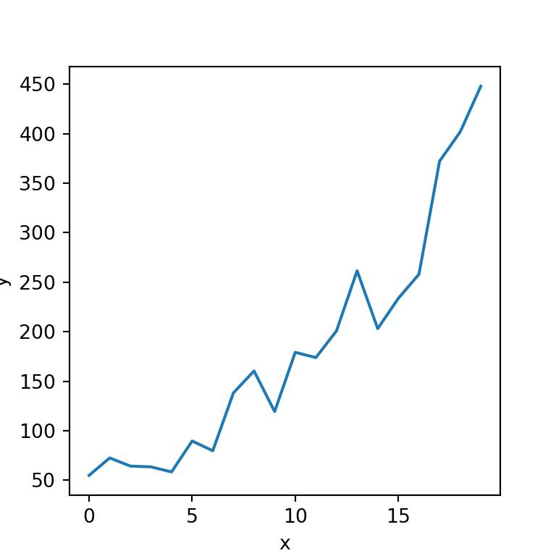
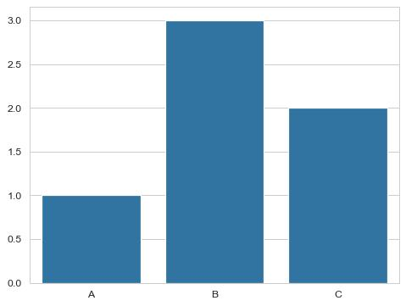
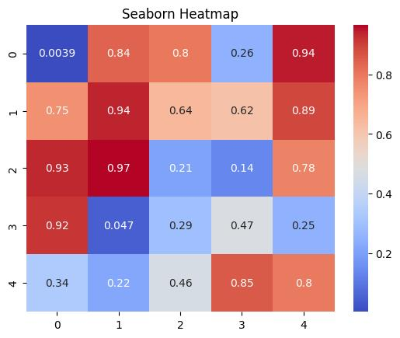
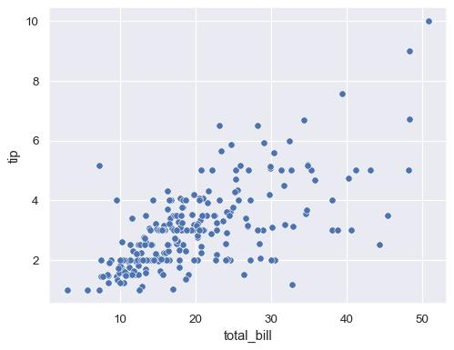

1. Line Plot
Program
import seaborn as sns
import matplotlib.pyplot as plt

x=[1,2,3,4,5]
y=[10,20,30,40,50]

sns.lineplot(x=x,y=y)

plt.show()
Purpose
- Creates line graph using Seaborn
- Useful for trend analysis

2. Bar Plot
Program
import seaborn as sns
import matplotlib.pyplot as plt

x=[1,2,3,4,5]
y=[10,20,30,40,50]

sns.barplot(x=x,y=y)

plt.show()
Purpose
- Creates attractive bar charts
- Used for value comparison

3. Scatter Plot
Program
import seaborn as sns
import matplotlib.pyplot as plt

x=[1,2,3,4,5]
y=[10,20,30,40,50]

sns.scatterplot(x=x,y=y)

plt.show()
Purpose
- Displays relationship between two variables
- Used for correlation analysis

4. Histogram
Program
import seaborn as sns
import matplotlib.pyplot as plt

y=[10,20,30,40,50]

sns.histplot(y)

plt.show()
Purpose
- Shows frequency distribution of data

5. KDE Plot
Program
import seaborn as sns
import matplotlib.pyplot as plt

y=[10,20,30,40,50]

sns.kdeplot(y)

plt.show()
Purpose
- Displays smooth density distribution curve

6. Box Plot
Program
import seaborn as sns
import matplotlib.pyplot as plt

y=[10,20,30,40,50]

sns.boxplot(y=y)

plt.show()
Purpose
- Represents data spread and outliers

7. Violin Plot
Program
import seaborn as sns
import matplotlib.pyplot as plt

y=[10,20,30,40,50]

sns.violinplot(y=y)

plt.show()
Purpose
- Combines box plot and density distribution

8. Heatmap
Program
import seaborn as sns
import matplotlib.pyplot as plt

data=[[1,2,3],[4,5,6],[7,8,9]]

sns.heatmap(data)

plt.show()
Purpose
- Represents matrix values using colors

9. Swarm Plot
Program
import seaborn as sns
import matplotlib.pyplot as plt

x=['A','A','B','B','C']
y=[10,20,30,40,50]

sns.swarmplot(x=x,y=y)

plt.show()
Purpose
- Displays categorical scatter distribution

10. Count Plot
Program
import seaborn as sns
import matplotlib.pyplot as plt

x=['A','B','A','C','B']

sns.countplot(x=x)

plt.show()
Purpose
- Counts repeated categorical values

Advanced Seaborn Graphs
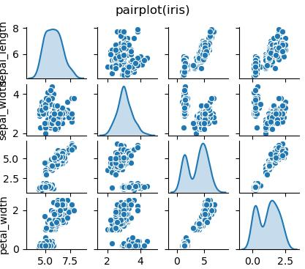
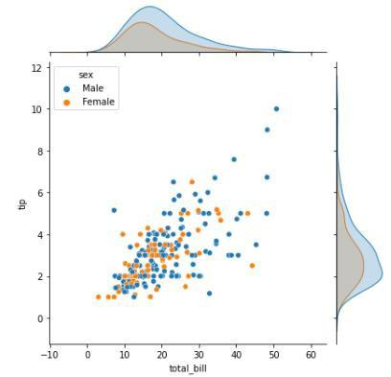
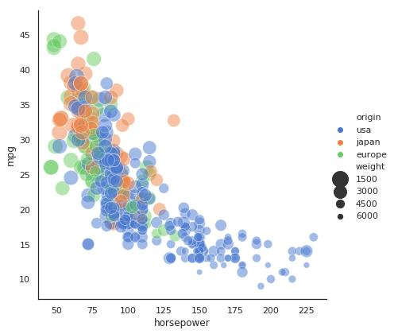
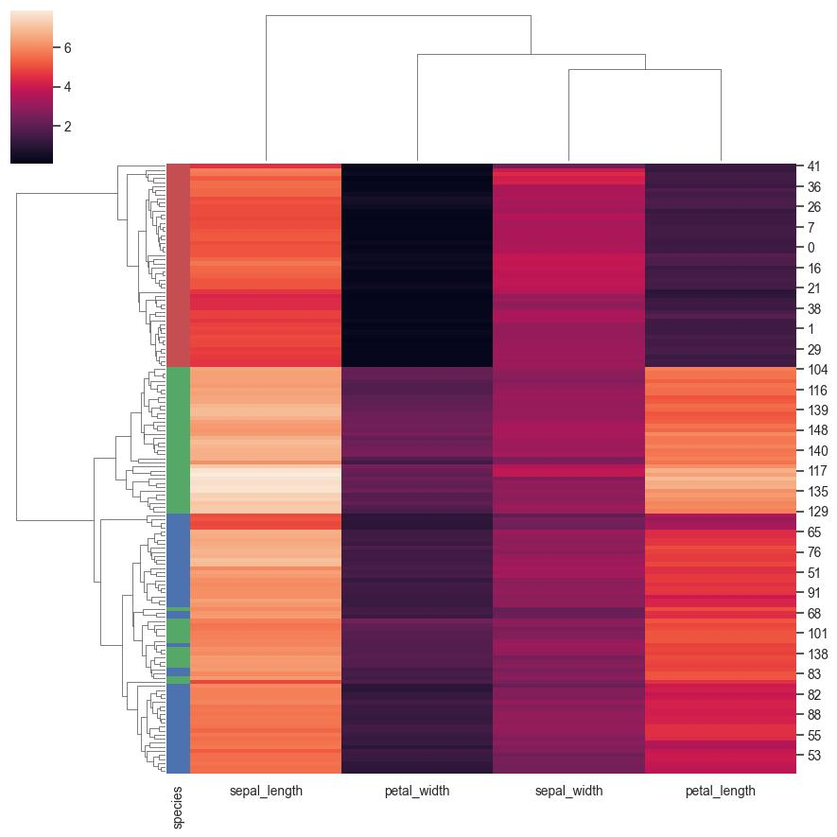
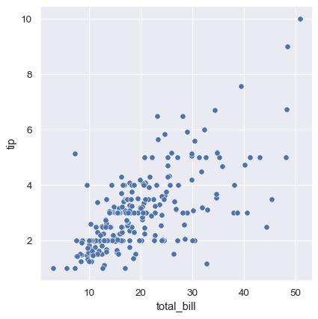
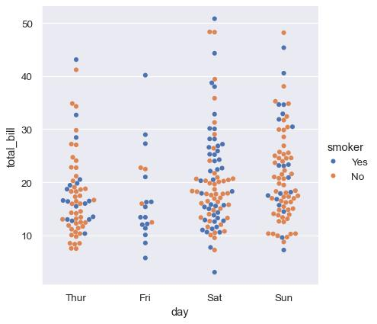

11. Joint Plot
Program
tips = sns.load_dataset("tips")

sns.jointplot(x="total_bill", y="tip", data=tips)

plt.show()
Purpose
- Shows relationship and distribution together

12. Cluster Map
Program
data = [[1,2,3],[4,5,6],[7,8,9]]

sns.clustermap(data)

plt.show()
Purpose
- Groups similar data using clustering

13. Relational Plot
Program
tips = sns.load_dataset("tips")

sns.relplot(x="total_bill", y="tip", data=tips)

plt.show()
Purpose
- Displays relationships between variables

14. Categorical Plot
Program
tips = sns.load_dataset("tips")

sns.catplot(x="day", y="total_bill", data=tips)

plt.show()
Purpose
- Used for categorical data visualization

15. Distribution Plot
Program
tips = sns.load_dataset("tips")

sns.displot(tips["total_bill"])

plt.show()
Purpose
- Displays data distribution graphically

16. Pair Plot
Program
iris=sns.load_dataset("iris")

sns.pairplot(iris)

plt.show()
Purpose
- Shows pairwise relationship between columns

17. Strip Plot
Program
import seaborn as sns
import matplotlib.pyplot as plt

c=['A','B','A','B','A']

sns.stripplot(x=c,y=y)

plt.show()
Purpose
- Displays distribution of categorical data points

Functions Available in Seaborn
- sns.lineplot()
- sns.barplot()
- sns.scatterplot()
- sns.histplot()
- sns.kdeplot()
- sns.boxplot()
- sns.violinplot()
- sns.countplot()
- sns.heatmap()
- sns.swarmplot()
- sns.stripplot()
- sns.pointplot()
- sns.regplot()
- sns.lmplot()
- sns.pairplot()
- sns.jointplot()
- sns.displot()
- sns.relplot()
- sns.catplot()

TASK 2 – Bar Chart Creation using Seaborn
A bar chart was created using student marks dataset.
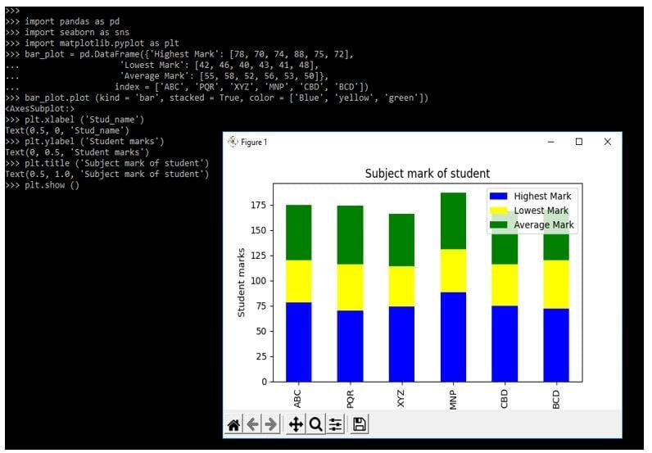
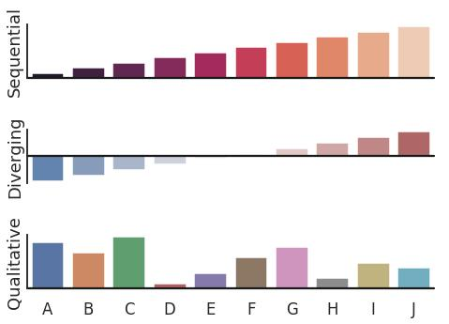
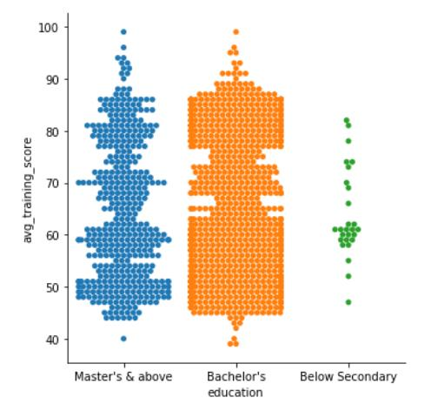
Introduction
Seaborn is a Python visualization library used to create attractive graphs easily. In this task, a bar graph was created using Seaborn to represent student marks visually.

Program
import seaborn as sns
import matplotlib.pyplot as plt

x=["A","B","C","D","E","F"]
y=[99,90,45,95,87,65]

sns.barplot(x=x,y=y,label="Student_Marks")

plt.legend()

plt.xlabel("Student Names")
plt.ylabel("Marks")

plt.show()

Output Description
- A bar graph displaying student names and marks was generated successfully
- Labels and legend were added for clarity
- Visualization improved comparison of student marks

Technologies Used
- Python
- Seaborn
- Matplotlib
- Google Colab
- Data Visualization

Learning Outcome
On Day 14, I learned how to create attractive statistical visualizations using Seaborn.
I understood:
- the difference between Matplotlib and Seaborn
- how Seaborn simplifies graph creation
- how to create statistical graphs using Seaborn functions
- how different graph types help analyze datasets visually
- how Seaborn improves visualization appearance automatically
Conclusion
The Day 14 internship session helped me understand the importance of Seaborn in data visualization. I learned the difference between Matplotlib and Seaborn and practiced creating different types of graphs such as line plots, bar plots, scatter plots, histograms, heatmaps, violin plots, pair plots, and categorical plots.
This session improved my understanding of statistical visualization and graphical representation techniques using Python.

